KWAME NKRUMAH UNIVERSITY OF SCIENCE AND TECHNOLOGY

COLLEGE OF ENGINEERING


DEPARTMENT OF CHEMICAL ENGINEERING

TITLE: ACID-BASE EQUILIBRIUM

NAME: AMPAW-ASIEDU MERCY

COURSE: BSC. CHEMICAL ENGINEERING

YEAR: SECOND YEAR

EXPERIMENT NO. : P.1.2.1.

I.D. NO: 3643609

T.A.: NESTA BOTTEY-SAM
DATE: 9TH MARCH, 2008.

Aims and Objectives:
- To be able to construct titration curves for strong and weak acids in their reactions with a strong base and
- Observe the different characteristics of the curves.
- To examine the behaviour of indicators during the titrations and determine the dissociation constant, K_{a} for an unknown weak organic acid.

INTRODUCTION
According to the Bronsted-Lowry’s definition, an acid is a species which donates a proton and a base is a species
which donates a proton and a base is a species which accepts a proton in aqueous solution (1), whereas a weak
acid is a substance which only partially dissociates (2). The difference between equations (1) and (2) below lies in
the extent of the reaction. The major species in (2) is HA, the undissociated weak acid, while the major species in
- Are the hydroxonium ion and A⁻ , the product of the reaction , the conjugate acid and base.

HA _{(aq)} + H₂0_{(l)} → H₃0⁺ _{(aq)} + A⁻_{(aq)} ………….. (1)

Whereas a weak acid is a substance which only dissociates partially in aqueous solutions as shown in the equation below:

HA _{(aq)} + H₂0_{(l)} → H₃0⁺ _{(aq)} + A⁻_{(aq)} ……. …… (2)

The difference between (1) and (2) lies in the extent of the reaction. The major species in (2 is HA, the undissociated weak acid, while the major species in (1) are H₃0⁺ _{(aq)} and A⁻_{(aq)} , the products of the is a conjugate acid and base.

For a strong monoprotic acid, the number of moles of A⁻ formed is equal to the number of moles of H₃0⁺ formed
(which is equal to the number of moles of HA dissociated). The same holds for the weak monoprotic acid but
these concentrations are small in comparison to the concentration of HA remaining in solution. Equilibrium lies
far to the in equation (2) and the extent of dissociation of the weak acid is described by K_{a}, the acid dissociation
constant.tdt

The acid dissociation constant (K_{a}) of an acid is:
K_{a} = [H₃0⁺][ A⁻] (3)
[HA]

Taking the negative log of each term, we then have:

-log K_{a} = -log [H₃0⁺] – log[A⁻] + [HA] (4)

The acidity of the solution can be described by a pH value defined as the negative logarithm of the hydroxonium ion concentration.

pH = -log [H₃0⁺] (5)

The negative log of the acid dissociation constant (K_{a}) also gives a constant, pK_{a}. Therefore (4) rearranges to:

pH = pK_{a} + log [Base] (6)
[Acid]

When a strong base is added to a strong acid, a weak acid and polyprotic acid considerable changes occur in terms of pHs.

The equivalence points of the different titration reactions will be determined using the pH meter but a different indicator will be for each one and from observations made from the aftermath of the reaction, it will be determined whether the indicator used was appropriate.

CHEMICALS AND APPARATUS
- Erlenmeyer flask
- Beaker
- Pipette
- Burette
- Retort stand
- pH meter
- Measuring cylinder
- Stirrer
- Concentrated NaOH solution, conc. HCl, HC₂H₃O₂, H₃PO₄ and an unknown organic acid.
- Distilled water

PROCEDURE AND TABLE OF RESULTS

PART A: TITRATION OF HCL (STRONG ACID) WITH NAOH.

- With the aid of a pipette, 25.00 ml of 0.100M HCl was transferred into a clean Erlenmeyer flask and 2 drops of an indicator was added after which about 75.00 ml of distilled water was also added.
- The acid solution was stirred thoroughly and the colour of the indicator was noted.
- The pH of the acid solution was measured after standardizing the pH meter with buffer solutions of 4.00 and 7.00.
- About 5.00ml of NaOH from the burette was added to the acid solution and the solution is allowed to mix and equilibrate and the pH was measured.
- NaOH was added 5.00ml at a time and the pH was measured after each addition.
- The pH range at which the indicator changed was also noted
- As the solution reaches equivalence point, smaller amounts of the NaOH was added to cause a change in pH.
- The titration is continued until the pH reaches about 12 to 14.

 | pH Values
Volume of 0.1M NaOH | A  (methyl red) | B  (methyl orange) | C  (Bromocresol green) | D (phenolphthalein)
0 | 2.05 | 3.87 | 2.90 | 2.90
5 | 2.97 | 4.87 | 3.40 | 3.02
10 | 3.00 | 5.29 | 5.40 | 3.27
15 | 3.07 | 6.98 | 7.00 | 3.25
20 | 3.20 | 7.39 | 8.01 | 3.36
25 | 3.65 | 7.43 | 10.52 | 3.62
30 | 10.52 | 7.48 | 10.84 | 5.05
35 | 10.90 | 7.50 | 11.02 | 5.75
40 | 11.15 | 7.52 | 11.13 | 6.15
45 | 11.30 | 7.53 | 11.17 | 6.41
50 | 11.42 | 7.55 | 11.31 | 6.69
55 |  | 7.60 | 11.35 | 7.30
60 |  | 7.61 | 11.45 | 10.50
65 |  | 7.76 | 11.45 | 11.10
70 |  | 8.33 | 11.54 | 11.40
75 |  | 8.45 | 11.55
80 |  | 8.55
85 |  | 8.58
90 |  | 8.75
95 |  | 8.82
100 |  | 8.93

CALCULATIONS/POST – LAB QUESTIONS:

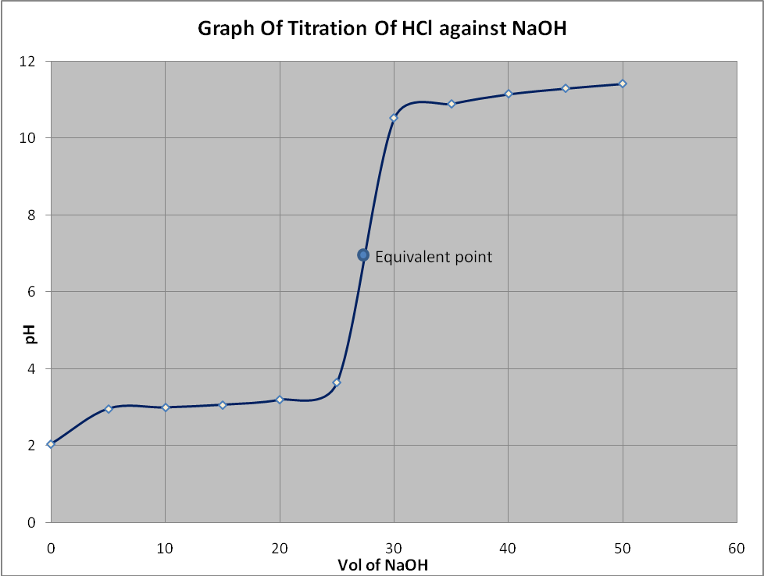

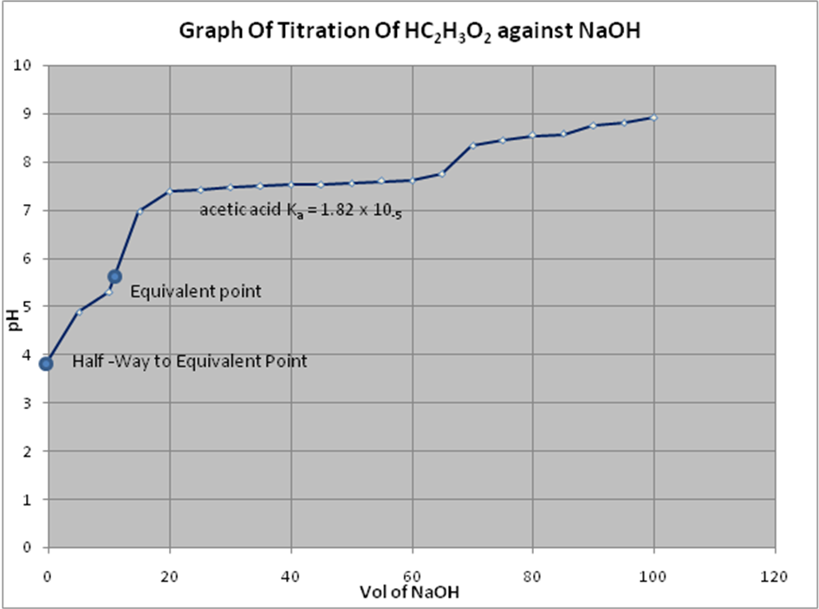

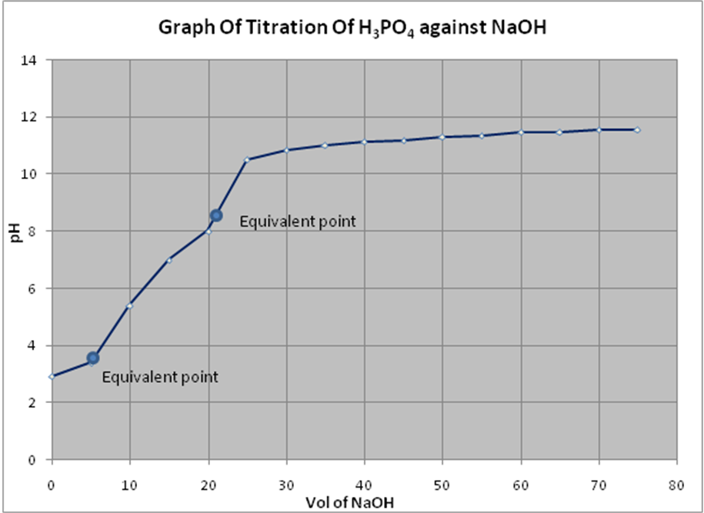

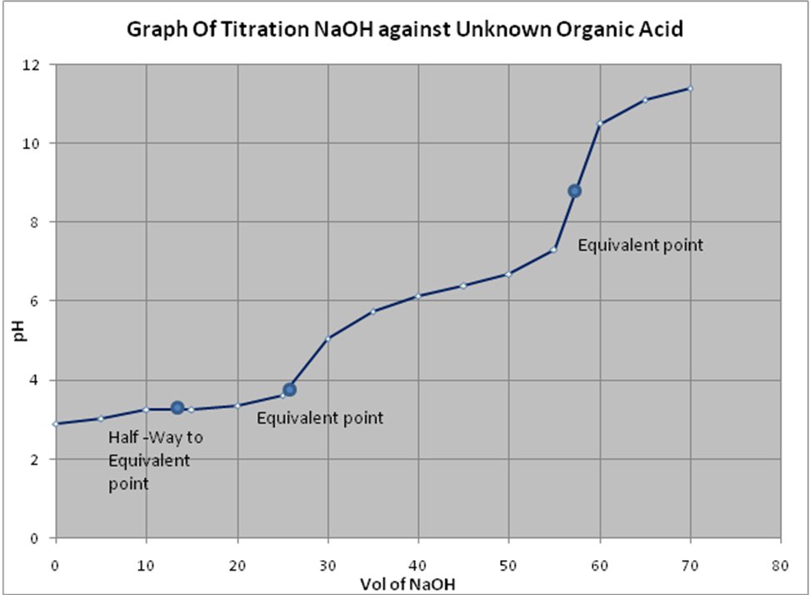

Differences:
The curve of acetic acid against NaOH rises sharply as compared to the curve of the phosphoric acid against NaOH.
The curve of acetic acid against NaOH rises has two equivalent points as compared to the curve of the phosphoric acid against NaOH which has just one equivalent point.

Similarities:
Both curves have their first equivalent points in the acidic region
Both curves end the basic region.

The half – way to equivalence point of the acetic acid maps on the graph to a pH of 3.5. This gives a pK_{a} value of 3.5 and a K_{a} value of 10^{-3.5} which equals 3.16 × 10⁻³.

The first and second half – way to equivalence point of the phosphoric acid maps on the graph to a pH of 3.2 and 5.8 respectively. This gives a pK_{a1} value of 3.2 and a K_{a1} value of 10^{-3.2} equal to 6.31 × 10⁻³ and a pK_{a2} value of 5.8 and a K_{a2} value of 10^{-5.8} equal to 1.58 x 10⁻⁶.

The first point from the graph is 3.0. Since this equals the pK_{a1}, the K_{a1} is 10^{-3.0} which equals 1 × 10⁻³. This value almost equals the K_{a1} value of 1.5 × 10⁻² for Malonic acid.
The second point from the graph equals 5.0. Therefore pK_{a2} equals 5.0 and K_{a2} is 10^{-5.0} which equals 1 × 10⁻⁵ and this is still quite close to the value of 1.5 × 10⁻² for Malonic acid.

For the strong acid (HCl) titration, methyl orange was used. Even though the range of its colour change (pink to colourless) does not occur at the equivalence point, it occurs on the vertical position of the curve, where a single drop of base causes a large pH change and this shows that the titration is within a fraction of a drop from the equivalence point.

For the weak acid (HC₂H₃O₂) titration, methyl red was used which changes colour ( pink to yellow) earlier and slower over a large volume (≈ 10ml) of titrant, thereby giving a vague and false indication of the equivalence point.

Phenolphthalein is suitable in this titration because its colour change lies within the range of the basic region.

For the polyprotic acid (H₃PO₄) titration, bromocresol green was used. From the results of the titration, there was a colour change from yellow to blue meaning that the indicator was not suitable for the titration.

For the unknown acid titration, phenolphthalein was used. The colour change from colourless to purple occurred at the basic region and this shows the acid is a weak one and the indicator was quite suitable for the titration.

PRECAUTIONS
- Safety glasses and aprons were worn in the laboratory the whole time.
- A few millimeters of the base was allowed to drain through the stop cork to flush out any trapped air bubbles.
- It was ensured that the electrode was rinsed with DI water before and after measurement.
- It was ensured that the stir bar did not collide with the electrode.

DISSCUSSION
In the titration of a strong base versus strong acid, the curve rises gradually initially and at 50cm³ there is a sharp increase in pH and finally remains constant to the end of the reaction. As the base is been added at the equivalence point the solution will be neutral. After the equivalence point is reached and, as additional amount of OH⁻ ion are added, the solution’s basicity continues to increase. The equivalence point is 7.00 and the half-way to the equivalence point is in the weak acid region.
For strong acid versus strong base, any indicator may be used which has a range between the limits pH 4.5 and 9.5. With 0.01M solutions, the pH range is some what smaller (5.5-5.8).

For Part B, (weak acid versus strong base), the curve rises gradually initially and there is a sharp increase in pH and finally remains constant to the end of the reaction. After the equivalence point is reached and, as additional amount of OH⁻ ion are added, the solution’s basicity continues to increase.
For weak acid versus strong base, the pH of the equivalence is calculated from the equation:
pH = 1pK_{w} + 1pK_{a} + 1pc
2 2 2
The pH range for acids with K_{a} > 10⁻⁵ is 7-10.5, and for weak base is K_{b} > 10⁻⁶, the range is reduced (8-10). The pH range 8-10.5 will cover most of the examples likely to be encountered; this permits the use of thymol blue, phenolphthalein.

For Part C, (phosphoric acid versus strong base), the phosphoric acid dissociates in a series of steps. The curve rises gradually initially and there is a sharp change of pH near the first equivalent point, but for the second and third stage the change was less pronounced. Each dissociation has its own equilibrium constant and will have an equivalence point on a titration curve. Neutralization proceeds almost completely to the end of the primary stage before the secondary stage is appreciably affected, and the secondary stage also proceeds almost to completion before the tertiary stage was apparent.

For Part D after the equivalence point has been reached, the solution contains excess of hydroxonium ions, the hydrolysis of the salt I suppressed, and the subsequent pH changes may be assumed, with sufficient accuracy, to be those due to the excess of acid present.

CONCLUSION
Phenolphthalein, methyl red were suitable for the titration whiles methyl orange and bromocresol green were not suitable indicators.
Also the unknown organic acid is Malonic acid.

REFERENCE
- CHEMISTRY: The Molecular Nature of Matter and Change by Martin Silberberg
- Vogel’s Textbook of Practical Organic Chemistry.
- CHEMISTRY: A contemporary Approach by Wesley. D. Smith and David. G. Lygre.

NAME: AMPAW-ASIEDU MERCY

COURSE: BSC. CHEMICAL ENGINEERING

YEAR: SECOND YEAR

EXPERIMENT NO. : P.1.2.1.

I.D. NO: 1314507

T.A.: NESTA BOTTEY-SAM
DATE: 2ND MARCH, 2011.

PRE-LAB
- Wearing safety gloves quickly remove the goggles from his or her face and wash thoroughly with
35cm³, there is a sharp increase in pH and at 40cm³, there is a steady increase of pH to the end of the reaction. As the base is added, the equilibrium position is shifted by the addition of the hydroxide ion.
The pH range of the reaction is 3-13. The equivalence point is 9.00 and the half-way to the equivalence point is in the strong acid region. There is also partial dissociation of the acid.

Similarities
The similarity between the two curves is there is a shifting of the equilibrium to the left as the amount of hydroxonium ion is no longer equal to the amount of A⁻ in solution in both reactions. In both curves the reaction ends in the basic region.

